Cybersecurity Fundamentals & Security Concepts

Week 3 Assignment
Name | Danish Javid
Department | Red Team ( Cyber security )
Institute | IT Simplera
Date | 17:07:2026
Instructor | Talal Rehman
Supervisor | Senior Cyber Security Analyst

Task 1:
Protocols and Port Numbers
This task is to understand common network protocols, their default port numbers, transport protocols (TCP/UDP), their purpose, and whether they provide secure or insecure communication. This knowledge is essential for networking and cybersecurity professionals to configure, troubleshoot, and secure network services.

1. HTTP (Hypertext Transfer Protocol)
- Port Number: 80
- Protocol: TCP
- Purpose: HTTP is used to open websites on the internet. It sends data between a web browser and a web server, but the data is not encrypted.
- Security: Insecure

2. HTTPS (Hypertext Transfer Protocol Secure)
- Port Number: 443
- Protocol: TCP
- Purpose: HTTPS is the secure version of HTTP. It encrypts the data between the browser and the website, making online activities safer.
- Security: Secure

3. FTP (File Transfer Protocol)
- Port Number: 21
- Protocol: TCP
- Purpose: FTP is used to upload and download files between two computers over a network. It is commonly used for website file management.
- Security: Insecure

4. SFTP (Secure File Transfer Protocol)
- Port Number: 22
- Protocol: TCP
- Purpose: SFTP is used to transfer files securely. It protects the data by using an encrypted SSH connection.
- Security: Secure

5. SSH (Secure Shell)
- Port Number: 22
- Protocol: TCP
- Purpose: SSH allows a user to remotely access and manage another computer in a secure way. It is mainly used by system administrators.
- Security: Secure

6. Telnet
- Port Number: 23
- Protocol: TCP
- Purpose: Telnet is used to remotely connect to another computer through the command line. Since it does not encrypt data, it is not considered safe today.
- Security: Insecure

7. SMTP (Simple Mail Transfer Protocol)
- Port Number: 25
- Protocol: TCP
- Purpose: SMTP is used to send emails from one mail server to another or from an email application to a mail server.
- Security: Insecure

8. DNS (Domain Name System)
- Port Number: 53
- Protocol: TCP/UDP
- Purpose: DNS converts website names, such as google.com, into IP addresses so that computers can find and connect to the correct server.
- Security: Insecure

9. DHCP (Dynamic Host Configuration Protocol)
- Port Number: 67/68
- Protocol: UDP
- Purpose: DHCP automatically gives an IP address and other network settings to devices when they join a network.
- Security: Insecure

10. TFTP (Trivial File Transfer Protocol)
- Port Number: 69
- Protocol: UDP
- Purpose: TFTP is used to transfer small files, especially configuration and boot files, within a local network.
- Security: Insecure

11. POP3 (Post Office Protocol Version 3)
- Port Number: 110
- Protocol: TCP
- Purpose: POP3 downloads emails from a mail server to a user's computer so they can be read even without an internet connection.
- Security: Insecure

12. IMAP (Internet Message Access Protocol)
- Port Number: 143
- Protocol: TCP
- Purpose: IMAP allows users to access and manage emails directly on the mail server, making them available on multiple devices.
- Security: Insecure

13. SNMP (Simple Network Management Protocol)
- Port Number: 161
- Protocol: UDP
- Purpose: SNMP helps network administrators monitor and manage devices like routers, switches, printers, and servers from one place.
- Security: Insecure

14. LDAP (Lightweight Directory Access Protocol)
- Port Number: 389
- Protocol: TCP/UDP
- Purpose: LDAP is used to store and manage user accounts and authentication information in organizations.
- Security: Insecure

15. RDP (Remote Desktop Protocol)
- Port Number: 3389
- Protocol: TCP
- Purpose: RDP allows users to remotely access and control a Windows computer as if they were sitting in front of it.
- Security: Secure
Task 2:
HTTP vs HTTPS Analysis
This task is to analysis different websites and determine whether they use HTTP or HTTPS. This task also helps understand how websites secure user data and whether they automatically redirect users from an insecure HTTP connection to a secure HTTPS connection.
1. Google (google.com)
- Protocol Used: HTTPS
- HTTP Redirect to HTTPS: Yes
- Connection Secure: Yes
Explanation:
Google automatically redirects users from HTTP to HTTPS. The connection is encrypted using SSL/TLS, which keeps user data safe during communication.

2. YouTube (youtube.com)
- Protocol Used: HTTPS
- HTTP Redirect to HTTPS: Yes
- Connection Secure: Yes
Explanation:
YouTube uses HTTPS to protect videos, login information, and user activity. Any HTTP request is automatically redirected to the secure version.

3. Facebook (facebook.com)
- Protocol Used: HTTPS
- HTTP Redirect to HTTPS: Yes
- Connection Secure: Yes
Explanation:
Facebook encrypts all communication with HTTPS to protect user accounts, messages, and personal information.

4. Wikipedia (wikipedia.org)
- Protocol Used: HTTPS
- HTTP Redirect to HTTPS: Yes
- Connection Secure: Yes
Explanation:
Wikipedia uses HTTPS to ensure secure access to its content and to prevent data from being modified during transmission.

5. GitHub (github.com)
- Protocol Used: HTTPS
- HTTP Redirect to HTTPS: Yes
- Connection Secure: Yes
Explanation:
GitHub uses HTTPS to protect source code, user accounts, and project data with encrypted communication.

6. Amazon (amazon.com)
- Protocol Used: HTTPS
- HTTP Redirect to HTTPS: Yes
- Connection Secure: Yes
Explanation:
Amazon secures customer accounts, payment details, and shopping information using HTTPS encryption.

7. Microsoft (microsoft.com)
- Protocol Used: HTTPS
- HTTP Redirect to HTTPS: Yes
- Connection Secure: Yes
Explanation:
Microsoft uses HTTPS to provide secure access to its websites and online services while protecting user information.

8. LinkedIn (linkedin.com)
- Protocol Used: HTTPS
- HTTP Redirect to HTTPS: Yes
- Connection Secure: Yes
Explanation:
LinkedIn uses HTTPS to secure user profiles, messages, and login credentials from unauthorized access.

9. Stack Overflow (stackoverflow.com)
- Protocol Used: HTTPS
- HTTP Redirect to HTTPS: Yes
- Connection Secure: Yes
Explanation:
Stack Overflow uses HTTPS to protect user accounts and ensure secure communication between users and the website.

10. OpenAI (chatgpt.com)
- Protocol Used: HTTPS
- HTTP Redirect to HTTPS: Yes
- Connection Secure: Yes
Explanation:
ChatGPT uses HTTPS to encrypt conversations and protect user data while communicating with the server.
Task 3:
Kali Linux Network Reconnaissance
This task is to perform basic network reconnaissance using Kali Linux. In this task, the ping command is used to test network connectivity, while Nmap is used to scan a target system, identify open ports, and detect the services running on those ports. This information helps security professionals understand the network and identify potential security risks.
Command 1: Check Connectivity
Ping google.com
Screen short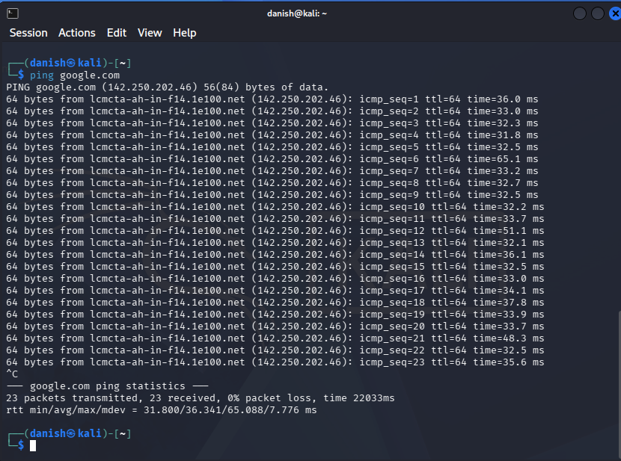
Purpose
The ping command is used to test whether a device can communicate with another device over a network. It also measures the response time and shows the TTL value of the received packets.
Response Time
- Minimum: 31.800 ms
- Average: 36.341 ms
- Maximum: 65.088 ms

TTL (Time To Live)
- TTL Value: 64
Command 2: Scan Scanme.nmap.org
scanme.nmap.org
Screen short
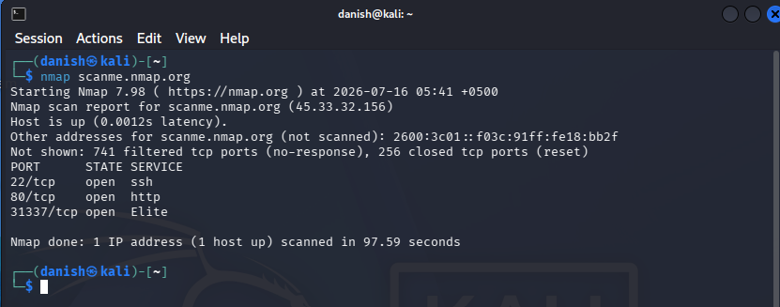
Purpose
The n map command is used to discover live hosts, identify open ports, and detect the network services running on a target system.

Results
Target Host
- Hostname: scanme.nmap.org
- IP Address: 45.33.32.156
Host Status
- Status: Host is Up
- Latency: 0.0012 seconds (approximately 1.2 m s)
Open Ports Found
- 22/tcp – Open
- 80/tcp – Open
- 31337/tcp – Open

Services Running on Open Ports
Port 22 (SSH)
Service: SSH (Secure Shell)
Purpose:
SSH is used for secure remote access and system administration. It encrypts communication between the client and the server, making remote management secure.

Port 80 (HTTP)
Service: HTTP
Purpose:
HTTP is used to deliver web pages and other website content to users through a web browser. It allows users to access websites over the Internet.

Port 31337 (Elite)
Service: Elite
Purpose:
Port 31337 is commonly used for testing or custom services. It is not a standard service port and may be used by developers for demonstrations or special applications.

Potential Security Risk
Port 80 (HTTP) can be a security risk because it sends data without encryption. If sensitive information is transmitted over HTTP, attackers may intercept the communication. Using HTTPS (Port 443) is a safer option because it encrypts data between the client and the server.

Command 2: Scan Local Ip

Nmap(10.0.2.15)

Screen short
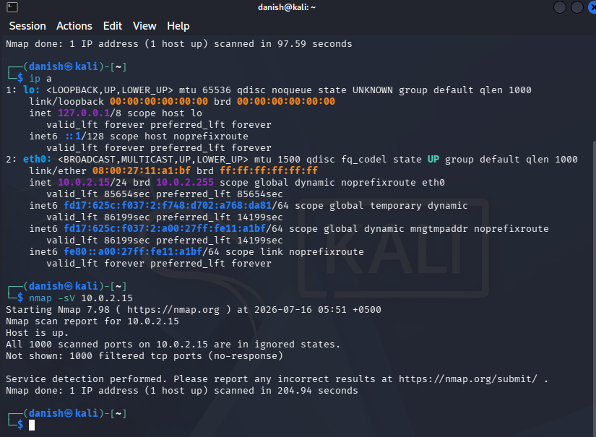
Target IP Address
10.0.2.15
Host Status
- Status: Host is Up
Open Ports Found
No open ports were detected.
Nmap reported:
- 1000 TCP ports scanned
- 1000 filtered ports (no response)
Services Running on Open Ports
No services were detected because there were no open ports available.

Potential Security Risk
No immediate security risk was identified because no open ports were found. Since all scanned ports were filtered, external systems cannot easily access services on this machine. This reduces the attack surface and provides better protection against unauthorized access.
Task 4:
What Happens When You Type a URL and Press Enter?
This task is to understand what happens behind the scenes when a user enters a website address (URL) into a web browser and presses Enter. Several networking processes work together to establish a secure connection, request the webpage, and display it in the browser.

1. DNS Lookup
When a user enters a URL such as www.google.com, the browser first checks whether it already knows the website's IP address. If not, it sends a request to a DNS (Domain Name System) server. The DNS server translates the domain name into its corresponding IP address.
Example:
www.google.com → 142.250.202.46

2. IP Address Resolution
After the DNS lookup is completed, the browser receives the website's IP address. This IP address tells the computer where the web server is located on the Internet so it can start communicating with it.

3. TCP Three-Way Handshake
Before sending any data, a TCP connection is established between the client and the server using three steps.
- Step 1 (SYN): The client sends a connection request.
- Step 2 (SYN-ACK): The server accepts the request and responds.
- Step 3 (ACK): The client confirms the connection.
After these three steps, a reliable connection is established.

4. TLS/HTTPS Handshake
If the website uses HTTPS, the browser and the server perform a TLS handshake.
During this process:
- The server sends its SSL/TLS certificate.
- The browser verifies that the certificate is valid.
- Both sides agree on encryption keys.
- A secure and encrypted connection is established.
This protects sensitive information such as passwords and payment details.

5. HTTP Request
Once the connection is ready, the browser sends an HTTP or HTTPS request to the web server.
The request asks for the webpage or other resources requested by the user.
Example:
GET / HTTP/1.1
Host: www.google.com

6. Server Response
The web server processes the request and sends back an HTTP response.
The response usually contains:
- HTML file
- CSS files
- JavaScript files
- Images
- Videos (if required)
It also includes a status code such as:
- 200 OK – Request successful
- 404 Not Found – Page not found
- 500 Internal Server Error – Server problem

7. Browser Rendering the Webpage
After receiving the response, the browser starts rendering the webpage.
It performs the following actions:
- Reads the HTML structure.
- Downloads CSS files for styling.
- Executes JavaScript for interactive features.
- Loads images, fonts, and other resources.
- Displays the complete webpage to the user.
This entire process usually takes only a few milliseconds.
Task 5:
Networking Cheat Sheet
This cheat sheet is to provide a quick reference to commonly used network protocols, their default port numbers, transport protocols, purposes, security risks, and secure alternatives. This helps network administrators and cybersecurity professionals identify services and understand secure communication practices.

Protocol Name | Port Number | TCP/UDP | Purpose | Security Risk | Secure Alternative
HTTP | 80 | TCP | Used to access websites | Data is sent without encryption | HTTPS
HTTPS | 443 | TCP | Secure web browsing | Low risk when configured correctly | N/A
FTP | 21 | TCP | Transfers files between systems | Usernames & pass. Are sent in plain text. | SFTP/FTPS
SFTP | 22 | TCP | Secure remote login & server Management | Very low risk | N/A
SSH | 22 | TCP | Remote access to a computer | Weak passwords may allow brute-force attacks. | SSH Keys +MFA
Telnet | 23 | TCP | Remote access to a computer. | No encryption; credentials can be intercepted. | SSH
SMTP | 25 | TCP | Sends emails between mail servers. | Email can be transmitted without encryption. | SMTPS (465) / STARTTLS
DNS | 53 | TCP/UDP | Converts domain names into IP addresses. | DNS spoofing or cache poisoning attacks. | DNS over HTTPS (DoH) / DNSSEC
DHCP | 67/68 | UDP | Automatically assigns IP addresses. | Rogue DHCP servers can provide fake network settings. | DHCP Snooping
TFTP | 69 | UDP | Transfers small files and device configurations. | No authentication or encryption. | SFTP
POP3 | 110 | TCP | Downloads emails from a mail server. | Login credentials are not encrypted. | POP3S(995)
IMAP | 143 | TCP | Accesses emails while keeping them on the server. | Data may be transmitted without encryption. | IMAPS (993)
SNMP | 161 | UDP | Monitors and manages network devices. | Older versions use weak or default community strings | SNMPv3
LDAP | 389 | TCP/UDP | Provides directory and authentication services. | Information can travel without encryption. | LDAPS(636)
RDP | 3389 | TCP | Remotely accesses Windows computers. | Can be targeted by brute-force attacks if exposed. | RDP with VPN+MFA
Task 6:
Kali Linux Web Enumeration

Website 1: Google (google.com)
whatweb google.com
whois google.com
Screen short
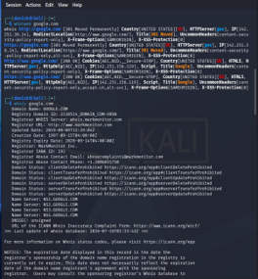 | 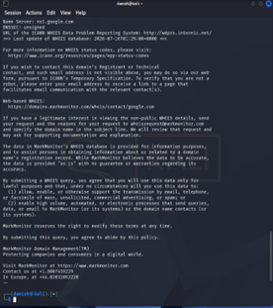

Website: google.com
Web Server / Technologies Detected:
- Google Web Server
- HTTPS Enabled
- HTTP Strict Transport Security (HSTS)
- HTML5
- HTTP/3 Support (if shown)
Domain Registrar:
- Mark Monitor Inc.
Registration Date:
- 1997 (Write the exact date shown in your output.)
Name Servers:
- ns1.google.com
- ns2.google.com
- ns3.google.com
- ns4.google.com
Interesting Information:
- Google forces HTTPS connections for secure communication.
- The domain uses multiple name servers for reliability and high availability.

Website 2: GitHub (github.com)
Commands
whatweb github.com
whois github.com
Screen short
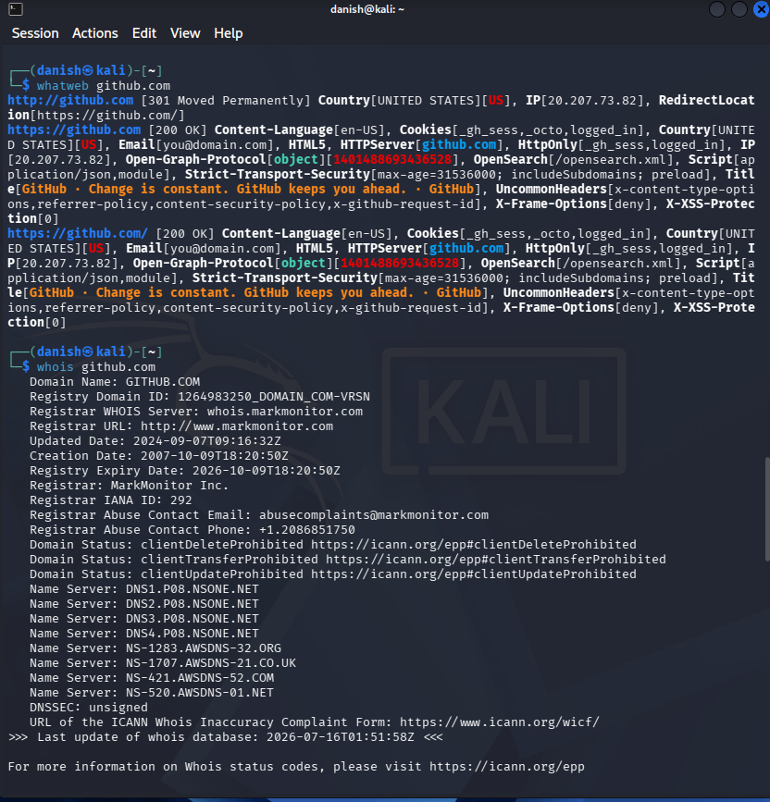 | 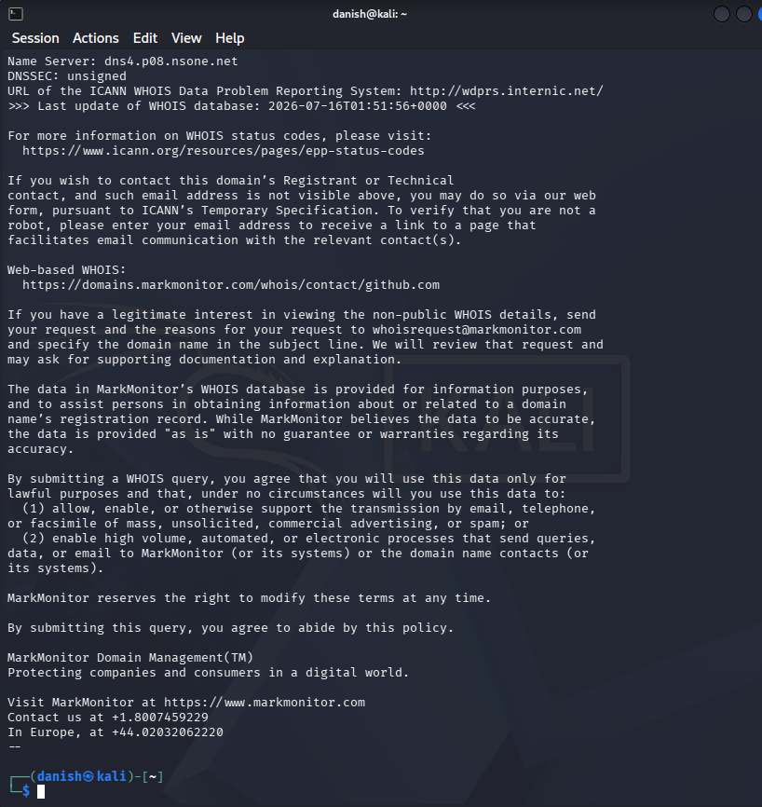

Website: github.com
Web Server / Technologies Detected:
- GitHub Web Server
- HTTPS Enabled
- HTML5
- HSTS
- Content Security Policy (CSP)
Domain Registrar:
- Mark Monitor Inc.
Registration Date:
- 2007 (Write the exact date shown in your output.)
Name Servers:
- dns1.p08.nsone.net
- dns2.p08.nsone.net
- dns3.p08.nsone.net
- dns4.p08.nsone.net
Interesting Information:
- GitHub uses HTTPS to secure user accounts and repositories.
- Security headers such as HSTS and CSP help protect the website from common web attacks.

